A River Parkway Event as Emergency Backup for EC3 Website Training on July 29, 2025

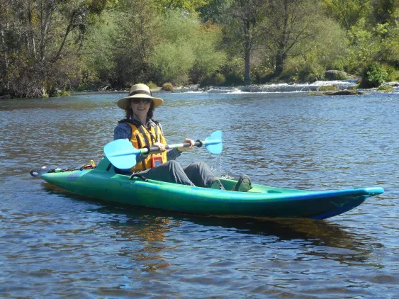
Evening Kayak Tour
Enjoy an adventure on the San Joaquin River! On this 3-hour downriver trip, you will paddle from Sumner Peck Ranch to Owl Hollow, located 3/4 mile behind the River Center. This portion of the river takes you along quiet, calm stretches, and through fun twists and turns. You will learn the basics of paddling, with time to practice in a calm area of the river before heading downstream. This trip is perfect for both new and experienced kayakers alike! Participants will meet their guide at the River Center to start the trip, then shuttle to Owl Hollow to drop off vehicles, then shuttle to the starting point at Sumner Peck.
Day: August 15, 2025
Time: 4:30 pm - 8:00 pm
Price: $55/participant
Participants: Maximum of 12 participants. Participants must register in groups of 2 or more to accommodate shuttling requirements. Ages 16+. Kayaks are single person boats.
Stretch: Sumner Peck to Owl Hollow

